Project Explanations

Building the Non-Inverting Amplifier
• Step 1: Place the Operational Amplifier (Op-Amp) on the breadboard and connect the power supply pins (typically V+ and V-) to the appropriate rails.
• Step 2: Connect the input signal source directly to the Non-Inverting (+) terminal.
• Step 3: Place the 1 kΩ resistor (R1) between the Inverting (-) terminal and the common ground.
• Step 4: Connect the 2 kΩ feedback resistor (R2) between the Output terminal and the Inverting (-) terminal. This creates a closed-loop system with a theoretical gain of:
Av = (1 + R2/R1) = 1+ (2k/1k) = 3
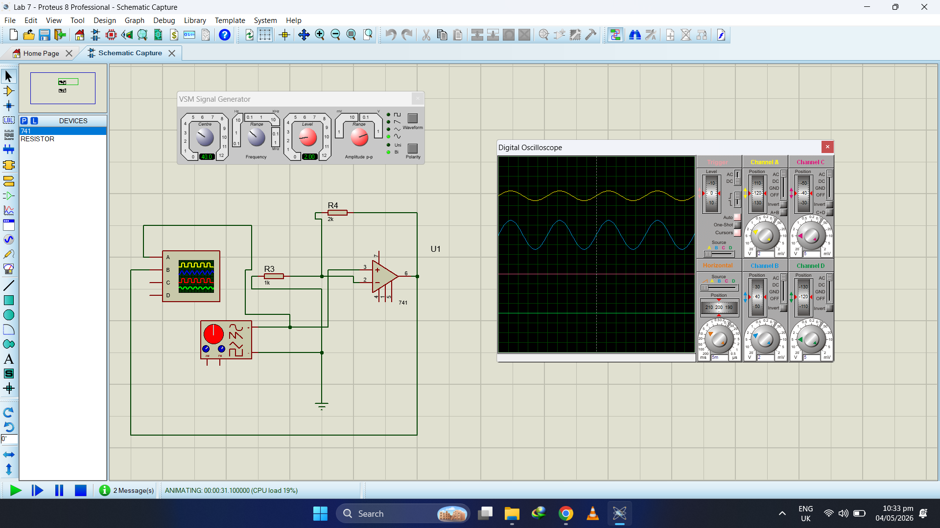

Building the Inverting Amplifier
• Step 1: Connect the Non-Inverting (+) terminal of the Op-Amp directly to the circuit ground.
• Step 2: Connect the input signal source to one end of the 1 kΩ input resistor (R1), and connect the other end of R1 to the Inverting (-) terminal.
• Step 3: Place the 3 kΩ feedback resistor (R2) between the Output terminal and the Inverting (-) terminal.
• Step 4: This configuration results in an inverted output with a theoretical gain of:
Av = -R2/R1 = -3k/1k = 3

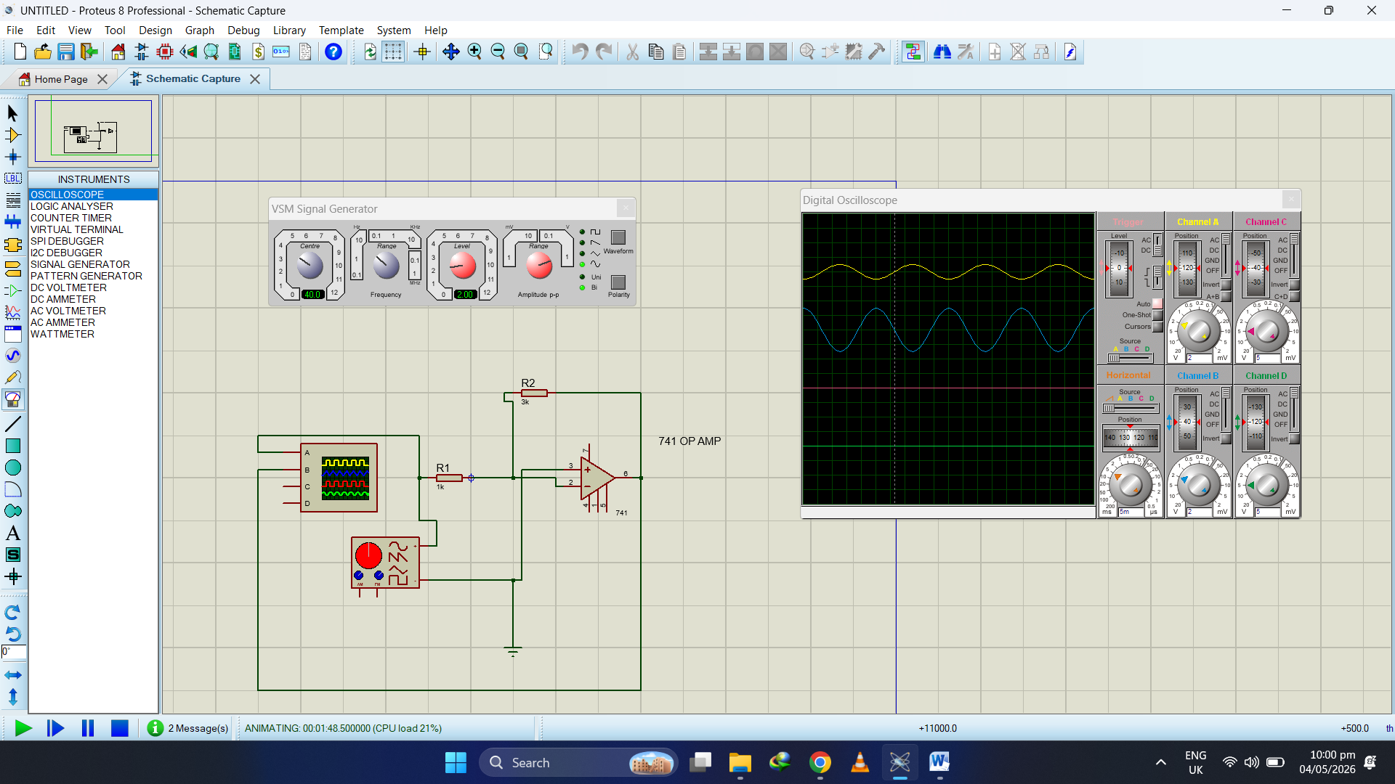

Building the Inverting Amplifier
Once the hardware connections were finalized, the following testing procedure was applied to both circuits:
- Input Signal: A Signal Generator was used to provide a Sine Wave with a peak-to-peak voltage of 2V and a frequency of 40 Hz.
- Measurement: An Oscilloscope was connected to the circuit. Channel 1 was used to monitor the input signal from the generator, while Channel 2 was connected to the Op-Amp's output terminal to observe the amplified waveform.
- Observation: The oscilloscope allowed for the real-time comparison of the input and output magnitudes and confirmed the phase relationship (in-phase for the first circuit and 180° out-of-phase for the second).

